“Entertaining Angels”
WELCOME HOME TO
Warwick River Mennonite Church

August 21, 2022
Note the New Service and Sunday School Times
for the Month of August
In-person and Virtual Worship Service: 9:00 a.m.
In-person and Virtual Coffee Connect follows Worship Service
In-person Sunday School: 10:30 – 11:30 a.m. (following Coffee Connect)
Recorded Sermons available at www.warwickrivermennonite.org

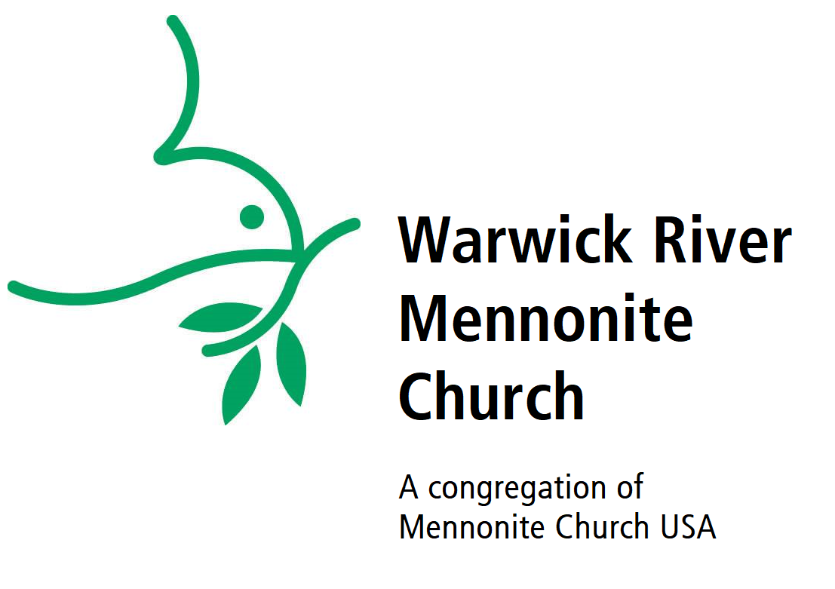

250 Lucas Creek Road, Newport News, VA 23602
757-874-0794
warwickriver@gmail.com
www.warwickrivermennonite.org

District Overseer – David Lehman
Church Elder – Tammara Geary Congregation Chair - Lisa Ziegler Christian Education Chair - Ann Aulich Stewardship Chair - Tom Salyers Fellowship Chair - Theresa Siebels Outreach Chair - Sue Yoder Worship Chair - Stuart Hunnicutt Members-at-Large - Laura Siebels &
Ursula Bock
Secretary - Pat O’Connor office hours: Tuesday – Friday, 9:30am – 3:30pm

Masks are required for everyone during Sunday Worship Service

Serving Today:
Guest Speaker: Pastor Howard Miller
Worship Leader: Susan Ackerman
Song Leader: Don Brunk
Reader: Chris Miller
Zoom Host: Leanna Schrock
Warwick River Mennonite Church
HOW TO CONNECT
*Worship Service * Sunday School * Meetings *
Computer: Click Here to enter Zoom Meeting
*MEETING ID: 846 7407 1811
*PASSWORD: 809884

Phone: 929-205-6099
*MEETING ID: 846 7407 1811
*PASSWORD: 809884

If you have any questions, feel free to reach out to
Mackenzie Butler Shenk (740-868-0016) or Don Brunk (610-787-0823)

-- Gathering --
Welcome
*Hymn of Praise and Gathering

Call to Worship:
Psalm 122 – See Bulletin Insert

*Hymn of Preparation

-- Hearing from God’s Word –

Scripture Reading: Hebrews 13:1-8; 15-16
Sermon Title: “Entertaining Angels” – Pastor Howard Miller

-- Responding to God’s Word --

*Hymn of Response
Sharing of Blessings and Concerns
Pastoral and Offertory Prayer
Offertory
Sharing of Announcements

-- Sending --
*Song of Sending
Benediction:

From Hebrews 13:
Now may the God of peace, who brought back from the dead our Lord Jesus, the great shepherd of the sheep, by the blood of the eternal covenant, make you complete in everything good so that you may do his will, as he works among us that which is pleasing in his sight, through Jesus Christ, to whom be the glory forever. Amen.

Attendance Report
August 14, 2022
Worship Service: 29 ~ Sunday School: 6

Offering Report August 14, 2022
$ 75.00 In-person Offertory totals this week toward FY2022
$ 100.00 In Memory of Kenny Ziegler
$ 400.00 Office + Mail Offertory totals this week toward FY2022
$ 575.00 Offertory Total 8/14/2022
Budget Offertory collected YTD 12/01/2021-08/14/2022= $86,042.62
Total Budgeted need 12/01/2021-08/14/2022=$136,409.01
Thank you for your continued gifts to God and Church
Honor the Lord with your wealth, with the firstfruits of all your crops.
Proverbs 3:9
Building News Corner
This Week’s Building Fund Update
08/07/2022 Building Fund Balance to date $ 1,532,538.05*
08/14/2022 0.00
08/14/2022 Building Fund Balance to date $ 1,532,538.05*
(*includes $12,947.05 estimated value stock shares)

Warwick River Mennonite Church
is grateful for your financial support and
committed to exercising faithful stewardship
over the funds contributed.
We are very aware of the many sacrifices you make to provide these gifts, and sincerely pledge to see that these dollars are used wisely.
To assist everyone in making consistent offerings that are
so important to your church, we are now able to accept
ACH savings/checking drafts and PayPal.
For PayPal, you may go directly to: Donate (paypal.com)

Prayer and Praise Requests:

- We extend a very special welcome and sincere thanks to our Guest Speaker, Pastor Howard Miller, for bringing the message this morning.

- Mennonite Mission Network began a new Enviados (Sent) cohort on Friday. Pray for participants in this Spanish-language, 12-module course for church planters. Pray, also, for the facilitator, Mauricio Chenlo, Mission Network’s training and resourcing specialist for church planting.

- Please pray for those among us who are grieving loved ones today. Whether their loss was long ago or recent, we remember their names, we remember their laughter, and we remember their sweet smiles. Please pray our Lord may comfort us in our time.

- As a new school year is upon us, we offer up prayer for our students to have clarity of thought in their studies, wisdom in decisions they make, and kindness in their relationships.

- Prayer and Praise concerns are always welcome & may be requested or updated by calling or emailing Pat O’Connor in the front office: (757)-874-0794 or warwickrivermc@gmail.com

Happy Birthday!
August 22 Twila Brunk // Rowan Hunnicutt
August 28 Ursula Bock
August 30 Leanna Schrock // Amy Longacher
August 31 Helene Portela

Happy Anniversary!
August 22 Stuart & Katherine Hunnicutt
August 24 Aaron & Myra Millikin
August 24 Noah & Rachael Shenk

Upcoming Events:
- Sun., Aug. 21st: Remember to vote today, via ballot - to determine the future of masking during Sunday Worship Service
- Sun., Aug. 21st: 9:00 a.m. Worship Service & Coffee Connect
- Sun., Aug. 21st: 10:30 a.m. Sunday School
- Tues., Aug. 23rd: 4:00 – 6:00 p.m. Community Prayer Group meets in the Warwick River Chapel
- Thurs., Aug 25th: 6:30pm on Zoom: Everence Webinar series begins

Announcements:

THRIVE Food Pantry Most Needed this month:
Crackers, Rice, Mac and Cheese, Spaghetti

Directory Update: Mary Anne Leonard has a new email address
Mary Anne Leonard: DLBL90@aol.com Please stay in touch!

